# Getting Started with KidsBlock Software

We will take Windows system as an example. As for MacOS system, just follow this instruction

1. Main Page

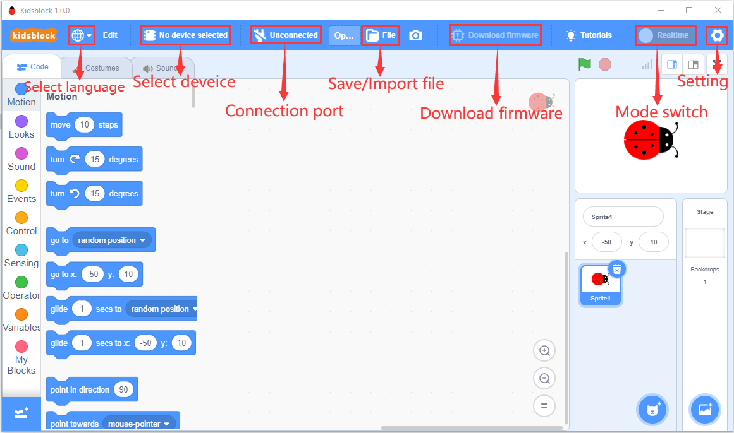

1. Click  to select the language

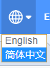

1. Click  to select“**Install driver”.**

(Note: **During driver installation, the CH341SER and CP210X drivers are installed by default**. If the computer has already installed the driver, just skip the following instructions.)

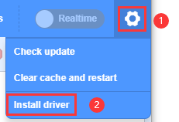

A.Then select "Next" on the "Device Driver Installation Wizard" page.

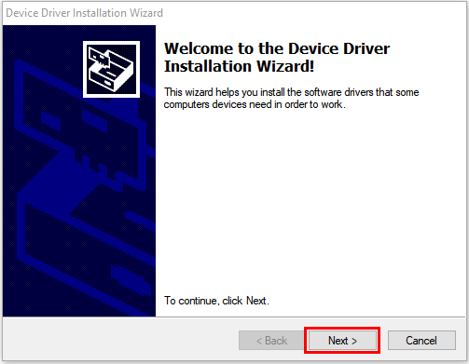

B. After a while, click on "**Finish**".

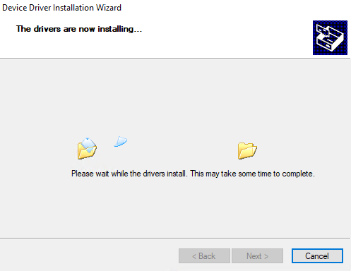

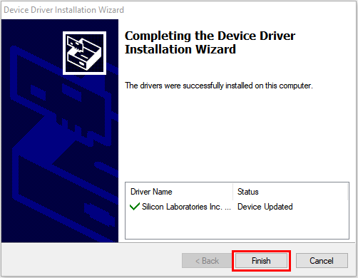

1. Click on "**Next**".

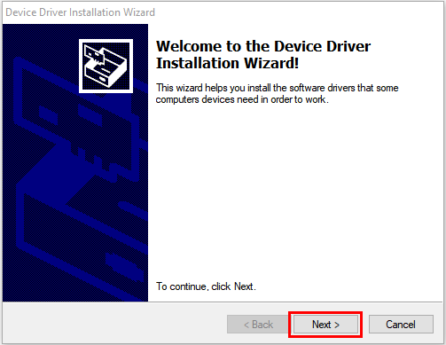

1. If a Windows Security page appears, choose“**Install**”. Then click“**Install**”.

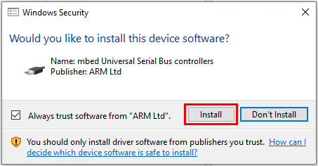

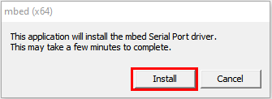

1. If the Windows Security page appears again , select“**Install**”.

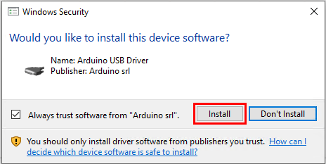

1. Click on "**Finish**".

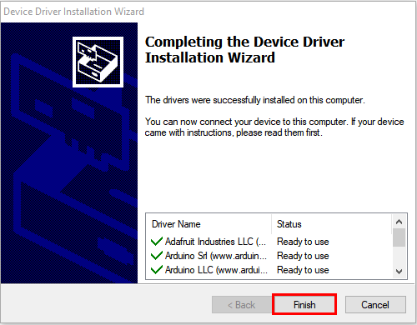

1. If a security page appears, choose“**Install**”. Then click“**Install**”.

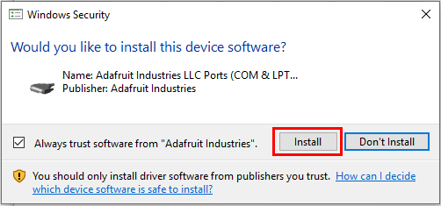



1. After a while, click "**Finish**".

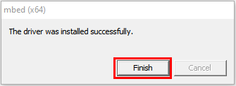

1. Click on“**Extract**”.

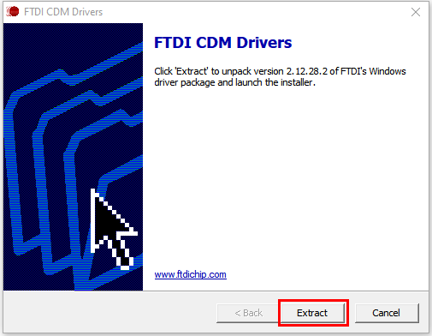

1. Click“**Next**”.

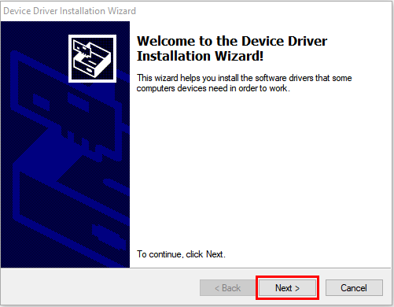

1. Select“**I accept this agreement**”and click“**Next**”.

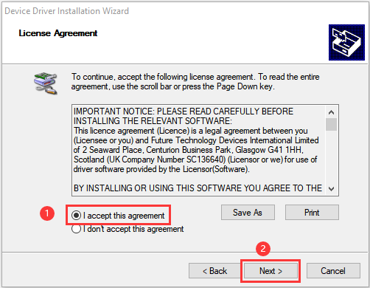

1. Click“Finish”.

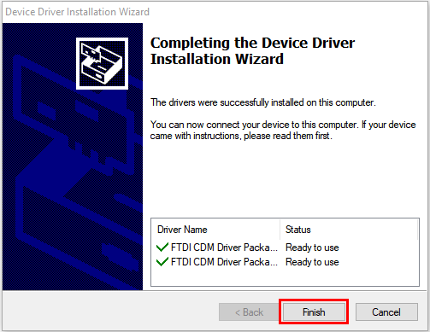

1. After a while, click“**INSTALL**”.

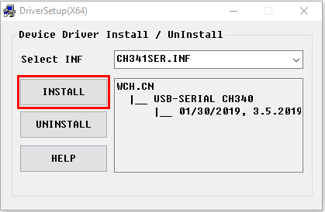

1. After a few seconds, the driver installation is complete, then click“**OK**”.

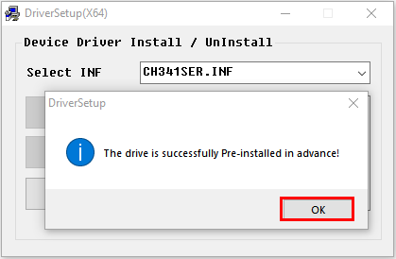

1. Then click  to enter the main page. You can select the needed control board . Plus motherboard is required for this project. Click the Plus board first, then click “**Connect**”. This means that the Plus board is connected.

Click“**Go to Editor**”to go back to the code editor. In this way, we will see that  become , and  turn into.

This indicates that the Plus motherboard and the port (COM) have been connected.

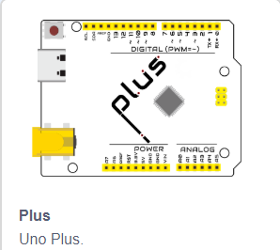

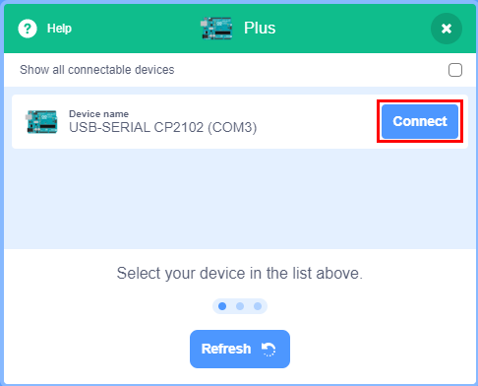

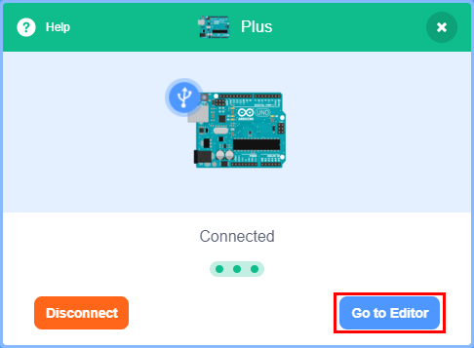

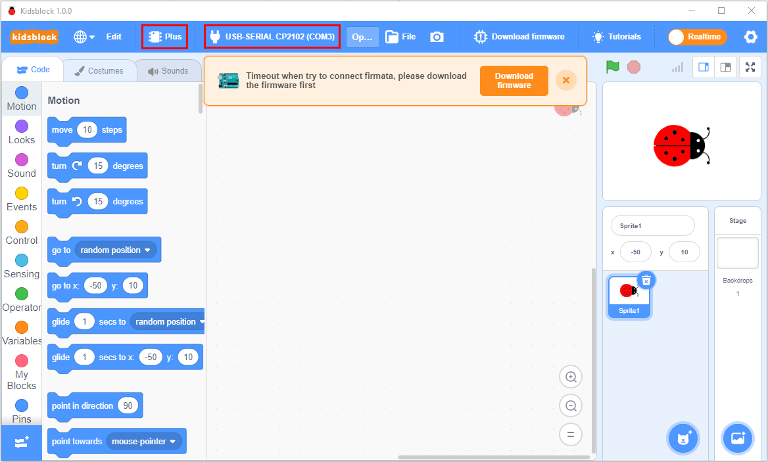

If the PLUS board has been connected, but the icondoesn’t turn into the icon, you need to manually clickto connect to the port (COM).

First click ，

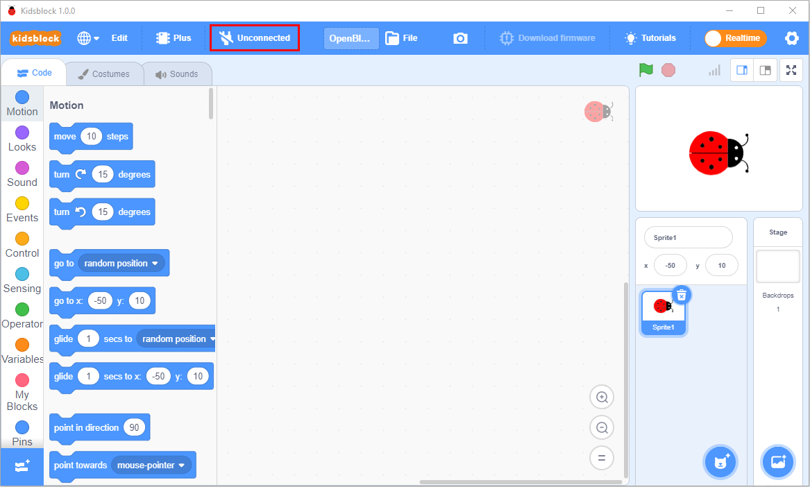

Then select“**Connect**”, as shown below;

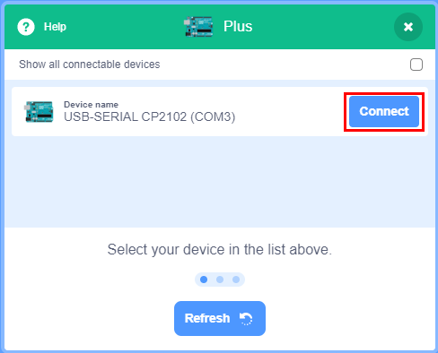

After successful connection, the "Connected" page will appear, which indicates that the port is connected.

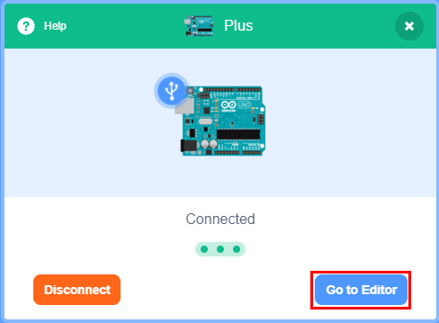

If you intend to disconnect the port, just click the icon

 and click“**Disconnect**”in the Plus page, as shown below:



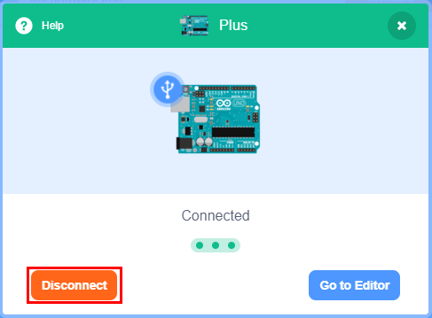

6. The PLUS motherboard and port (COM) are connected, then click  to switch the mode, then the mode switches into .

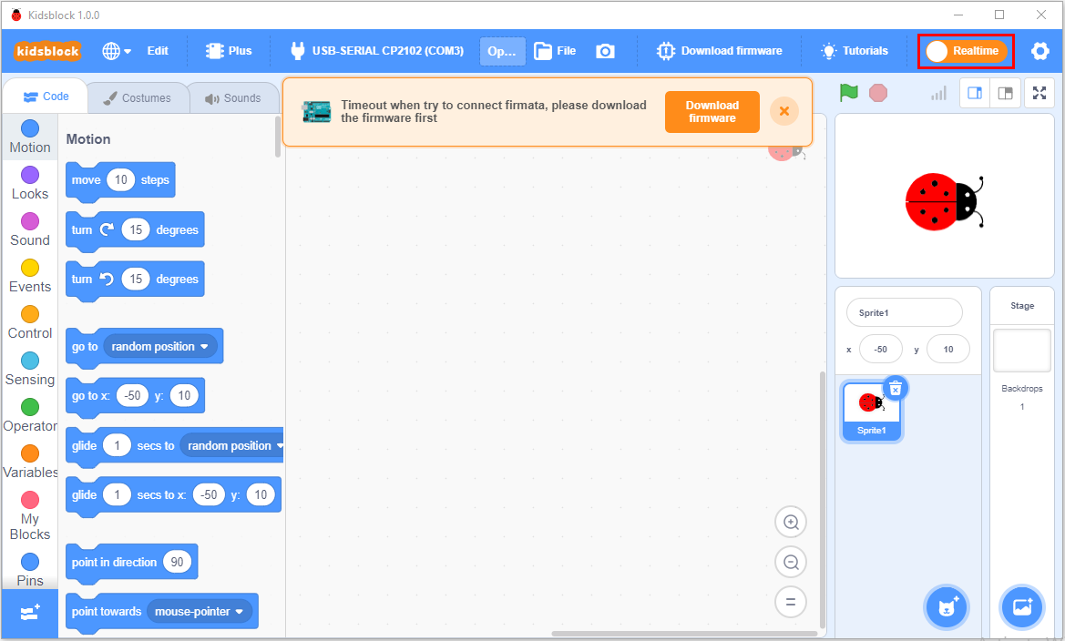

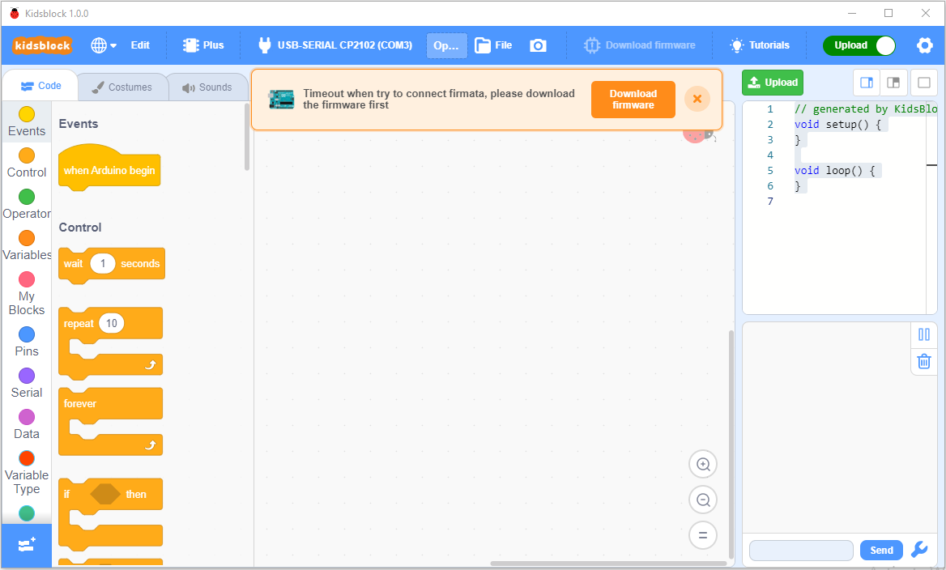

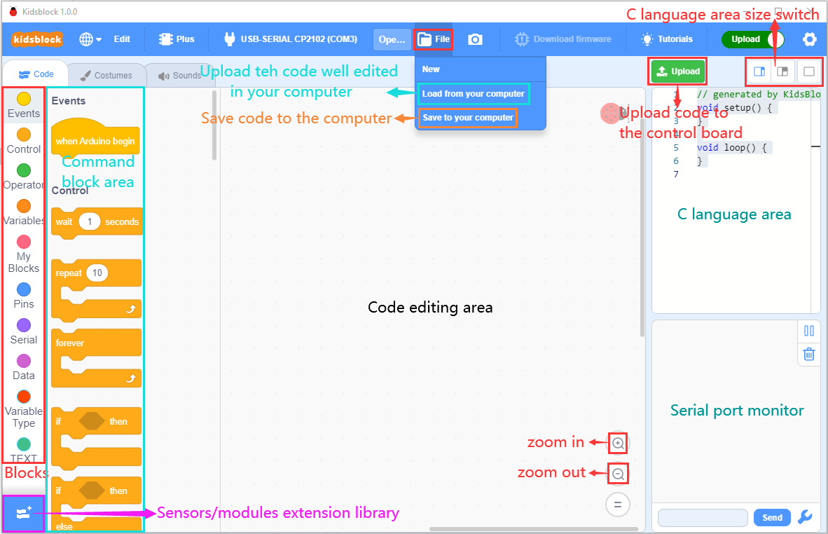

1. 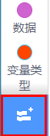 is used to add extension.

Click to enter extension library interface, and then click a sensor or module to add its corresponding extension. For example, if you need to add a passive buzzer, click "Passive Buzzer" module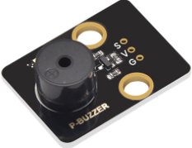. Then“Not loaded”becomes“Loaded”, which means that the "Passive Buzzer" module is successfully added.

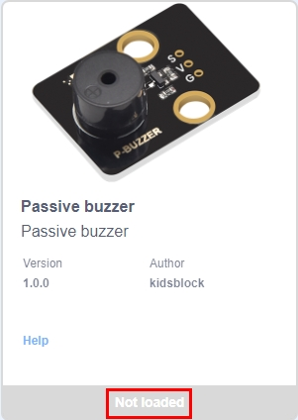 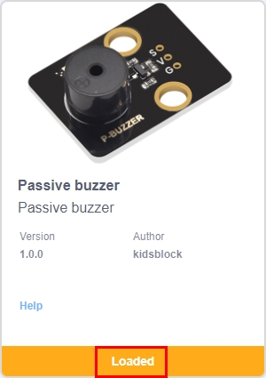

Click  to return to the code editor interface, and you can see the added "passive buzzer" command block in the blocks list.

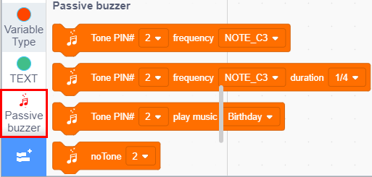

If you intend to delete the "Passive buzzer", just click  to enter the extension library interface again, and click the "passive buzzer" module . Then“Loaded”becomes ”Not loaded”, which means that the "passive buzzer" module has been deleted successfully.

 

1. Methods to Open Existing SB3 Type Files

Method 1: Double-click the SB3 type files, which can open the SB3 type file.

For example, if you want to open the file, just double-click it.

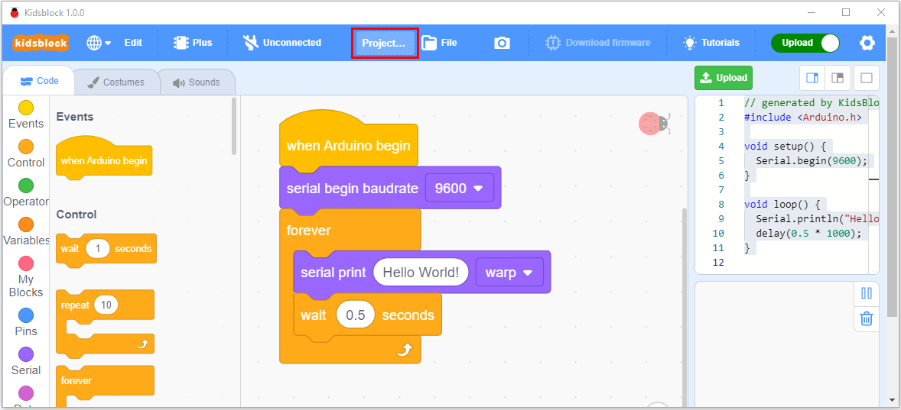

Method 2: Open the Kidsblock software, first click“**file**”, then“**Load from your computer**”，select the SB3 type file you need to open on your computer. (e.g.: file)

